Week 4 assignment

1. Description of Stochastic Process Theory

For our project, we have been considering the vertical acceleration of a quarter-car model system as our response signal, as a result of our random load, which was the vertical displacement of the road surface. Below we will reason the assumptions made around these choices, and why they are valid.

* 1. The Road Profile

Like stated previously in our project, the major factor for the in-car vibrations affecting our system is the road surface fluctuations, being vertical displacement of road profile our associated random load. The intention is to analyse its roughness, being the deterministic factor of the road type, when it comes to investigating vertical vibrations in the vehicle.

Road roughness also defines road data spectrum, again, defining difference between road types, and serving as data for further probability analysis and application of stochastic processes. However, road profile spectral characteristics cannot be used alone in car vibration analysis, since it has been proven to be non-stationary, non-gaussian process which contains transient parts. These transient parts are caused by random data such as potholes or road bumps, which do not cause most vehicle vibrations we are interested in, and therefore can be considered insignificant for our case. This could also be caused by potential irregularities of the measuring itself, in the road section, and therefore can be neglected, not considered part of the definition of “road roughness” itself. In other word, stationary load of road profile represents road surface roughness.

Also, the internal friction between the road and the vehicle was neglected, in order to simplify the process. This is a common practice in quarter-car suspension model studies, even though impact of road-friction coefficient exists, due to its minimal effect.

* 1. The Vehicle Model

In order to make our calculations and procedures sensible and realistic and due to the advantages in terms of design simplicity, and how it is commonly used in literature for vehicle response analysis, a quarter-car model system was selected for the purpose of the project. From here, the response spectrum is obtained, being this the vertical displacement of the suspension system. Certain assumptions were made prior to the mathematical definition of the system:

* Quarter car body parts are rigidly connected to each other.
* Quarter car moves in a horizontal direction in a straight line with a constant selected velocity.
* The present masses are considered constant in magnitude during analysis.
* Uneven road surface and road irregularities are responsible for vibration transfer in quarter car model in vertical direction. [8]

This last point takes us back to our random variable, being, the road surface, discussed deeper in section 1.1

Figure 1. shows a diagram of our model, and below, and the mathematical equations related to the dynamic state of the model, which can be stated using Newton’s second law of motion.

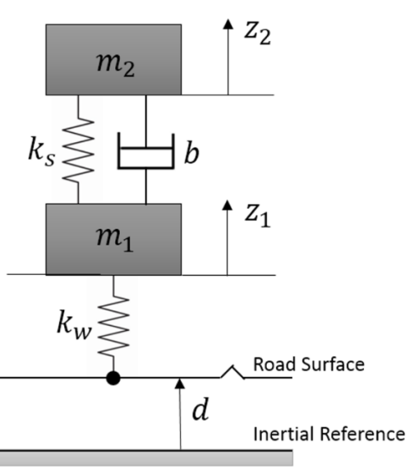

**Fig. 1.** model of quarter vehicle [6]

Equations of motion of the model are given by:

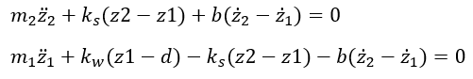

Where the parameters are:

* ks – suspension stiffness
* kw – tyre stiffness
* b– suspension damping coefficient
* m1 – un-sprung mass
* m2 – sprung mass
* d– distance between road profile and inertial reference constants
* z1 – displacement of the unsprung mass
* z2 – displacement of the sprung mass

Below are presented the mathematical equations in the state space form:

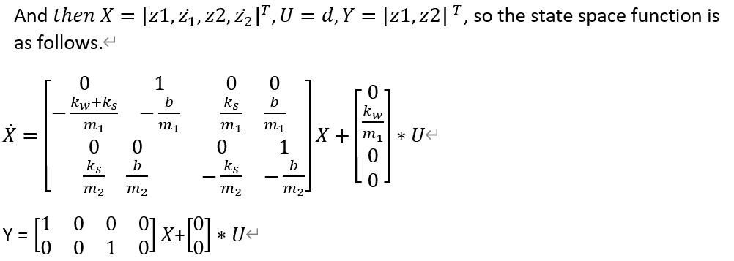

* 1. Load and response spectrum and RAO

Below, load and response spectrum and RAO are presented:

* Parameters values for the variables are selected as,
  + m1=10;
  + m2=350;
  + kw=500000;
  + ks=10000;
  + b=500

The transfer function:

$F=\frac{71430 s + 1429000}{s^{4}+\frac{5143}{100}s^{3}+51030s^{2}+71430s+1429000}$

Where F is the transfer function of semi-active suspension system for our model.

The RAO could be shown as following function and we defined the RAO here as |H(w)|2, so

In order to describe random response by applying RAO, power spectral density (PSD) of loading must be derived. In addition, when PSD is used as the sole description of road surfaces, transient parts are lost. [7] According to paper [3], the simplest analytical description of PSD is

$$Sxx(Ω)={CΩ}^{-w}$$

where Ω [rad/m] is the angular spatial frequency, Ω=2π/L, where L is wavelength, C is unevenness index and w is the waviness (wavelength deviations).

When it comes to the spectrum of the response of the vehicle, we consider the response of the whole suspension system under random loading with following equation,

$Syy ={|H(w)|}^{2}*Sxx{=|H(w)|}^{2}*{CΩ}^{-w}$

, where $Syy$ is response spectrum, ${|H(w)|}^{2}$ is RAO and $Sxx$ is loading spectrum

1. Stochastic process analysis
   1. Random load and response signal

In order to acquire amplitude scaling factor for creating random response and loading signals, post-processing must be done for the defined PSDs. Thus, square root was applied to PSD’s, since PSD is a function of square of wave amplitude divided by the frequency. The scaling factor spectrums and RAO of the damping system are displayed in Fig. **2**.



**Fig. 2**. Scaling factor spectrum for random loading and response of the loading of the system. RAO of damping system displayed at below.

Then according to ISO8608, frequency range for the defined load spectrum is 0.011 cycles/m to 2.83 cycles/m [3]. With the limits and scaling factor spectrums, random loading and response signals could be simulated. Examples of simulated road profile and system response can be seen in figure 3.



**Fig 3.** Random loading and response curves simulating a real road profile.

* 1. Time average, standard deviation and autocorrelation

In order to define if the process is stationary, probability distributions of time averages must be studied. If a process is stationary, mean value and standard deviation are not functions of time. The time averaging of the simulation results can be seen in

**Fig. 4** and **Fig. 5**. The time averaging is done with 1000 simulated measurements at distance of 1 meter and 10 meters. From the figures it can be seen that mean value and standard deviations have only slight changes at different time instances in loading time averages. So, it is safe to say that the random loading is a stationary process when number of ensembles approximate to infinity. However, standard deviation of response of the system changes between different time instances. Thus, the response of the system is a weakly stationary process.



**L = 1 m:**

mu = -0.08**,** σ = 2.39

**L = 10 m:**

mu = 0.03**,** σ = 2.34

**Fig. 4.** Time averaging for random loading. Mu stands for mean value and σ standard deviation. Time instances of travel distance at 1 meter and 10 meters are selected.

**L = 1 m:**

mu = -0.17**,** σ = 2.82

**L = 10 m:**

mu = 0.13**,** σ = 3.25



**Fig. 5.** Time averaging for response of the system. Mu stands for mean value and σ standard deviation. Time instances of travel distance at 1 meter and 10 meters are selected.

Then, to study the randomness of the process autocorrelation function is applied to the generated load and response signals. Autocorrelation can be used to determine whether the elements of a time series are unrelated to each other. In other words, the tool defines if a process is fully deterministic or random. The indicator for defining the randomness of the process is decay rate of the autocorrelation plots. The faster decay is, or the faster sampled autocorrelation goes from one to zero, the more deterministic process is.

Autocorrelation plots of a generated random load and response can be seen from **Fig. 6**. The lag range is 100 meters (resolution of 0.001). In our case, both load and response autocorrelation plots fluctuate near zero and slowly decays over travel length. Thus, the process is not fully random or deterministic but in somewhere middle.

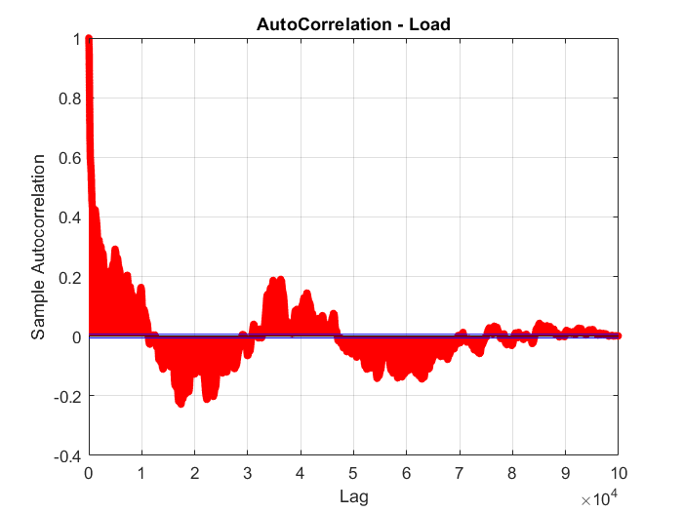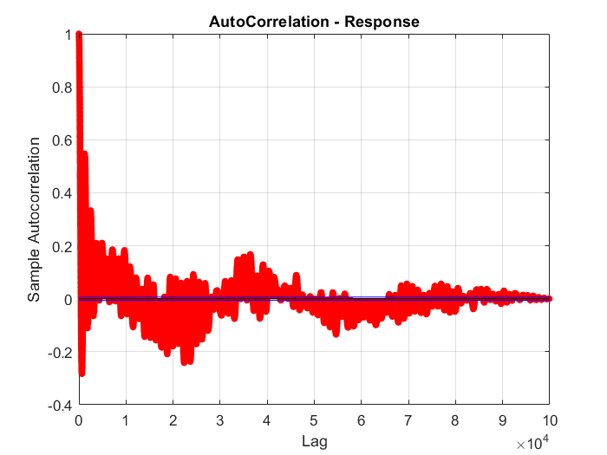

**Fig. 6.** Autocorrelation plots of both a random loading and response correlating to the load.

* 1. Probability distribution

If we plot a histogram of random signal data (from figure 3) for loading and response, we can see that the shape is close to the normal probability distribution. Two approaches have been used to fit a continuous curve to random signal data. According to figures 7 and 8, reds lines symbolise normal probability distribution for calculated standard deviations. The black curve is created using MATLAB function polyfit to fit a curve to the random signal data. Standard deviations for normal distribution fitting are (Calculated in MATLAB):

* Standard deviation of load = 2.6856
* Standard deviation of response = 3.9021



**Fig.7.** Continuous distribution over the loading displayed as histogram. Polynomial fitting and normal distribution fitting are applied to the histogram.



**Fig. 8.** Continuous distribution over the response displayed as histogram. Normal distribution fitting is applied to the histogram.

These curves fit better to the random signal data if we have longer signal. Obviously, the length of the signal influences these fits, because the more signal data we have, the more stochastically accurate we are. The effect of signal discretisation is not as big as the effect from the length of signal and we need to consider if it’s necessary to use huge discretisation because of computing time.

In paper [2], it is shown that probability distribution (PD) of road elevation of transient free road sections sets in Gaussian distribution. In some simplified case we can obtain loading and response probability distribution by normal distribution, which considering the road roughness in that case. For the loading distribution the curve fits very satisfactory that is caused by fact that we can consider road elevation as a stationary (the main part represents road roughness). Situation is worse in response distribution because there is not negligible transient part and so the normal distribution curve does not fit so well.

* 1. Rainflow analysis

Rainflow cycle counting is usually used in fatigue analysis to assess real stress cycles from the time history and to consider non-zero mean values. The reason for using Rainflow analysis is that we can compute exactly from the time history number of cycles at a certain value. For the stationary Gaussian process, we assumed in our report we get a shape reminding Rayleigh distribution by Rainflow analysis as it is displayed in figure 9. It is important to analyse enough long random signal to get sensible results. From the cycle counting we can see which are the most common values for car vertical displacement and we can use this information as said before for design and fatigue analysis of some components.

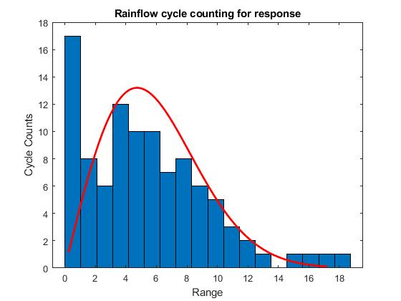

**Fig. 9.** Rainflow analysis for random response

In figure 10 is plotted rainflow cycle counting for the random load signal. We can fit to that the curve of random load PSD according to paper [3]. This is obvious because rainflow analysis counts cycles in the certain range from the signal history and we are assuming the load spectrum of the road profile analytically as exponential function (chapter 1.2). However, there only road roughness is considered and because of that, assumption is quite logical. If we drive a vehicle, there is a lot of small displacement on the road, less of bigger ones and so on.

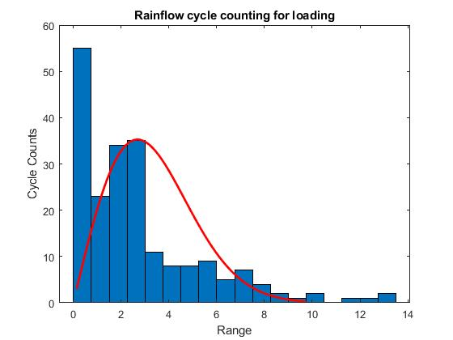

**Fig. 10.** Rainflow analysis for random loading

**Reference**

[1] Næss, A. & Moan, T. (2013). *Stochastic dynamics of marine structures*. Cambridge [England]: Cambridge University Press.

[2] Rouillard, V., Sek, M. A. & Bruscella, B. (2001). Simulation of Road Surface Profiles. Journal of Transportation Engineering, 127(3), pp. 247-253. doi:10.1061/(ASCE)0733-947X(2001)127:3(247)

[3] Kropáč, O. & Múčka, P. (2008). Deterioration Model of Longitudinal Road Unevenness Based on its Power Spectral Density Indices. Road Materials and Pavement Design, 9(3), pp. 389-420. doi:10.1080/14680629.2008.9690125

[4] Sulaymon Eshkabilov, Abduvokhid Yunusov, Measuring and Assessing Road Profile by Employing Accelerometers and IRI Assessment Tools, *American Journal of Traffic and Transportation Engineering*. Vol. 3, No. 2, 2018, pp. 24-40. doi: 10.11648/j.ajtte.20180302.12

[5] Qin, Y., Dong, M., Zhao, F., Langari, R. & Gu, L. (2015). Road profile classification for vehicle semi-active suspension system based on Adaptive Neuro-Fuzzy Inference System.

[6] Assignment1, ELEC-8103 – Modelling, Estimation, and Dynamic Systems  
[7] Bruscella, B., Rouillard, V. and Sek, M., 1999. Analysis of road surface profiles. Journal of Transportation Engineering, 125(1), pp.55-59.

[8] Chapter V, Mathematical Modeling of Quarter Car System, n.d,

<https://sg.inflibnet.ac.in/bitstream/10603/209993/6/chapter%205.pdf>, last seen 9th October 2020